**Task No. 1:** Find the company’s name that placed order 10290. (Tables: Customers & Orders)

**Solution:** SELECT CompanyName from Customers where CustomerID =

(select CustomerID from Orders where OrderID=10290)

**Output:**

**Task No. 2:** Find the Companies that placed orders in 1997 (Tables: Customers & Orders)

**Solution:** SELECT CompanyName from Customers where CustomerID in

(select CustomerID from Orders where year(OrderDate)=1997)

**Output:**

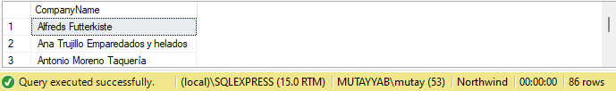

**Task No. 3:** Create a report that shows the product name and supplier id for all products supplied by Exotic Liquids, Grandma Kelly's Homestead, and Tokyo Traders. (Tables: Products & Suppliers)

HINT: You will need to escape the apostrophe in "Grandma Kelly's Homestead." To do so, place another apostrophe in front of it. For example,

SELECT * FROM Suppliers WHERE CompanyName='Grandma Kelly‘’s Homestead’;

**Solution:** SELECT SupplierID,ProductName from Products as p where SupplierID in (select SupplierID from Suppliers as s where CompanyName in ('Exotic Liquids','Grandma Kelly''s Homestead'

,'Tokyo Traders'))

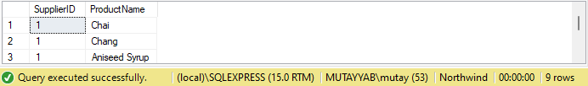**Output:**

**Task No. 4:** Create a report that shows all products by name that are in the Seafood category. (Tables : Products & Categories)

**Solution:** select ProductName,CategoryID from Products where CategoryID in

(select CategoryID from Categories where CategoryName ='Seafood')

**Output:**

**Task No. 5:** Create a report that shows all companies by name that sell products in CategoryID 8. (Tables: Supplier & Products)

**Solution:** select CompanyName from Suppliers where SupplierID in

(select SupplierID from Products where CategoryID = 8)

**Output:**

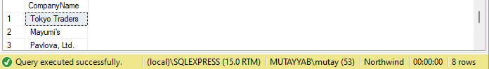

**Task No. 6:** Create a report that shows all 5companies by name that sell products in the Seafood category.(Tables: Suppliers, Products & Categories)

**Solution:** select CompanyName from Suppliers where SupplierID in

(select SupplierID from Products where CategoryID =

(select CategoryID from Categories where CategoryName='Seafood'))

**Output:**

**Task No. 7:** Write query using a “sub query” to display which Customers were served by which Employee use Northwind.

**Solution:** Select ContactName, A.OrderID, firstname+' '+Lastname as Employee FROM (select Orderid,ContactName from orders left join Customers on Orders.CustomerID=Customers.CustomerID) A inner join ( select OrderID,FirstName,LastName from Orders left join employees on Orders.EmployeeID=Employees.EmployeeID)B on A.Orderid=B.Orderid

**Output:**

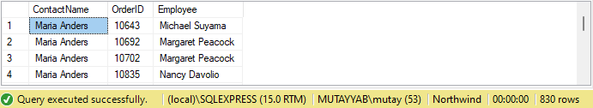

**Task No. 8:** Write query using a “sub query” to list of all the stores that have discount records use pubs.

**Solution:** select a.stor_id,a.stor_name ,b.discount from stores as a,discounts as b where a.stor_id in (select b.stor_id from discounts)

**Output:**

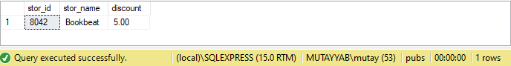

**Task No. 9:** Write query using a “sub query” to name publishers have got titles in store in Seattle? Use pubs.

**Solution:** select pub_id,pub_name from publishers where pub_id in

(select pub_id from titles where title_id in (select title_id from sales where stor_id in (select stor_id from stores where city ='Seattle')))

**Output:**

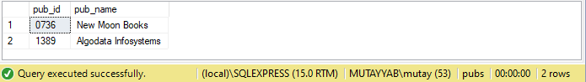

**Task No. 10:** Write query using a “sub query” to list all the authors available in Barnum’s store use pubs.

**Solution:** select au_fname+' '+au_lname as [Full Name] from authors where au_id in (select au_id from titleauthor where title_id in (select title_id from sales where stor_id in (select stor_id from stores where stor_name like 'ba%')))

**Output:**

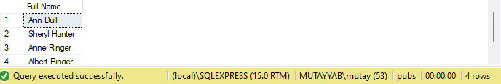

**Task No. 11:** Write query using a “sub query” to give the customer id and amount spent of the customer who spent the most using Northwind.

**Solution:** select CustomerID,max(Quantity*UnitPrice) as [Highest Price] from Customers,[Order Details] where CustomerID in (select CustomerID from Orders where OrderID in (select OrderID from [Order Details] WHERE UnitPrice*Quantity in (select MAX(UnitPrice*Quantity) from [Order Details] ))) group by CustomerID

**Another Solution**

SELECT A.CustomerID, UnitPrice*Quantity AS Highest_price FROM (SELECT Orders.OrderID,Customers.CustomerID FROM Orders INNER JOIN Customers ON Customers.CustomerID = Orders.CustomerID)A INNER JOIN (SELECT Orders.OrderID, UnitPrice, Quantity FROM Orders INNER JOIN [Order Details] ON Orders.OrderID = [Order Details].OrderID WHERE UnitPrice*Quantity IN (SELECT MAX(UnitPrice*Quantity)FROM [Order Details]))B ON A.OrderID = B.OrderID

**Output:**

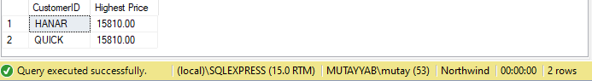

**Task No. 12:** Write query using a “sub query” to list all Northwind customers who have not placed an order.

**Solution:** (select CustomerID,ContactName from customers) except (select CustomerID,ContactName from customers where customerid in (select Orders.CustomerID from Orders))

**Output:**

